Command for inserting it:

db.books.insertMany(

[{"ISBN":"999-888","Book":"The secret river","Author":"Kate Grenville", "Review":[{"Reviewer": "Hua Tang","Score":"7"},{"Reviewer": "Jim Wong","Score":"8"},{"Reviewer": "Andrea Bauer","Score":"6"}]},

{"ISBN":"777-222","Book":"Fooled by randomness","Author":"Nassim Taleb", "Review":[{"Reviewer": "Simon Jones","Score":"5"},{"Reviewer": "John Messum","Score":"10"}]}]

)

screenshot:

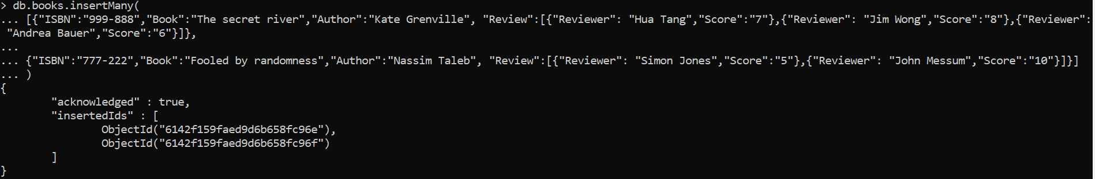

To show how it looks like actually in storage, the find() command can be run along with pretty()

